**PAN AFRICAN UNIVERSITY**

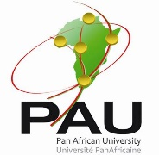

**INSTITUTE FOR BASIC SCIENCES, TECHNOLOGY AND INNOVATION**

**DEPARTMENT OF MOLECULAR BIOLOGY AND BIOTECHNOLOGY**

**MSc. MOLECULAR BIOLOGY AND BIOTECHNOLOGY**

**COURSE:**

**PUB 3120: Research Methodology and Proposal Development**

**LECTURER:**

**Prof J.Wesonga**

**ASSIGNMENT 1**

**NAME:**

# ID#: MB300-000/2024

SEPTEMBER 2025